Marble Roller Coaster Project
Overview
This project involved the design, construction, and testing of a scaled-down roller coaster model for a marble, simulating a full-size roller coaster system. The aim was to explore engineering principles such as gravitational potential energy, momentum conservation, and dynamics, while also practicing sketching, prototyping, and data logging.
The roller coaster integrates various track features—including a loop-the-loop, banked bends, and hills—calculated and constructed to maintain a smooth and stable speed for a marble throughout the ride. A light gate timer and stop contact system were incorporated and connected to a computer to allow for accurate data collection and performance analysis.

Sketch 1: Conceptual Design
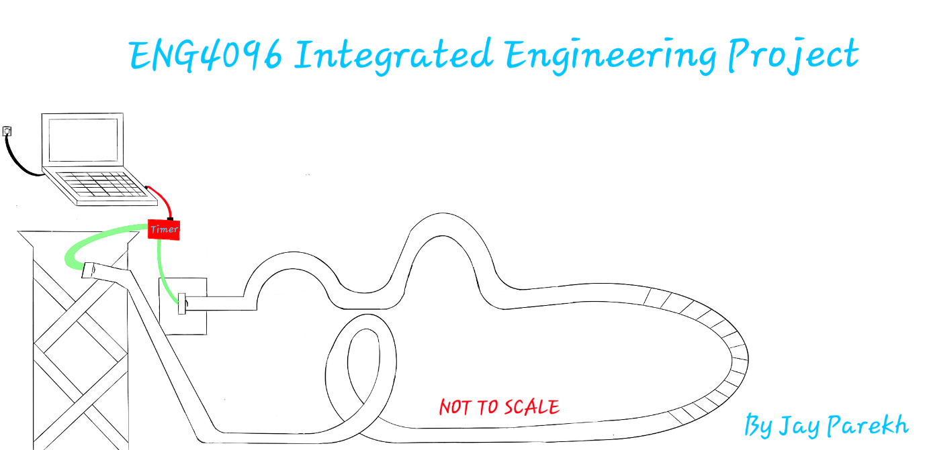Sketch 1 presents the initial concept of the roller coaster. It shows:
- A start tower fitted with a light gate that begins the timer as the marble is released.
- A calculated slope, designed to give just enough gravitational potential energy for stable speed without excessive acceleration.
- A loop-the-loop followed by a banked hairpin turn, designed for continuous motion.
- A taller hill followed by a smaller hill to simulate a realistic ride profile.
- A contact stop mechanism at the finish line that stops the timer upon marble impact.
This sketch represents the theoretical layout of a scaled roller coaster and helped guide the physical build.

Sketch 2: Component Detail Drawings
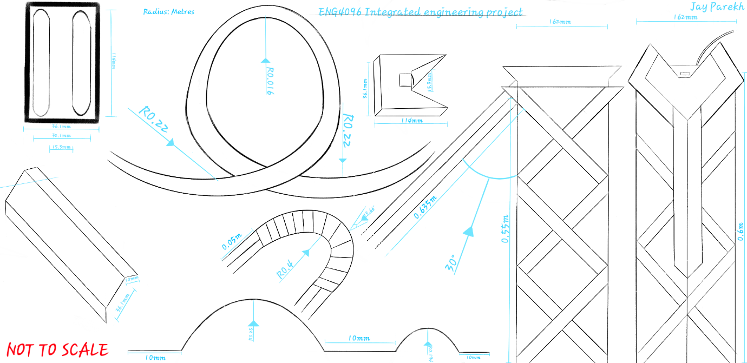Sketch 2 includes detailed, dimensioned drawings of the key components:
- Track Buildup (upper and lower left): Shows the structure of the track built from card and lollipop sticks. The card sags to form a channel for the marble, with 10mm folded edges acting as barriers.
- Loop-the-Loop (center): Precisely dimensioned for sufficient centripetal force to allow the marble to complete the loop without detaching or stalling.
- Banked Bend (center): Angled and dimensioned to provide stability during high-speed turning.
- Hills (center): Designed with varying heights to demonstrate energy loss and conversion between potential and kinetic energy.
- Start Slope and Tower (right): Complete with pitch angle and support structure to ensure consistency and accuracy in each test run.
- Safety Catch (next to loop): A contingency structure to stop the marble if it gains too much speed and risks derailing.
This sketch ensured each part was accurately fabricated and fit the design parameters.

Sketch 3: Final Assembly
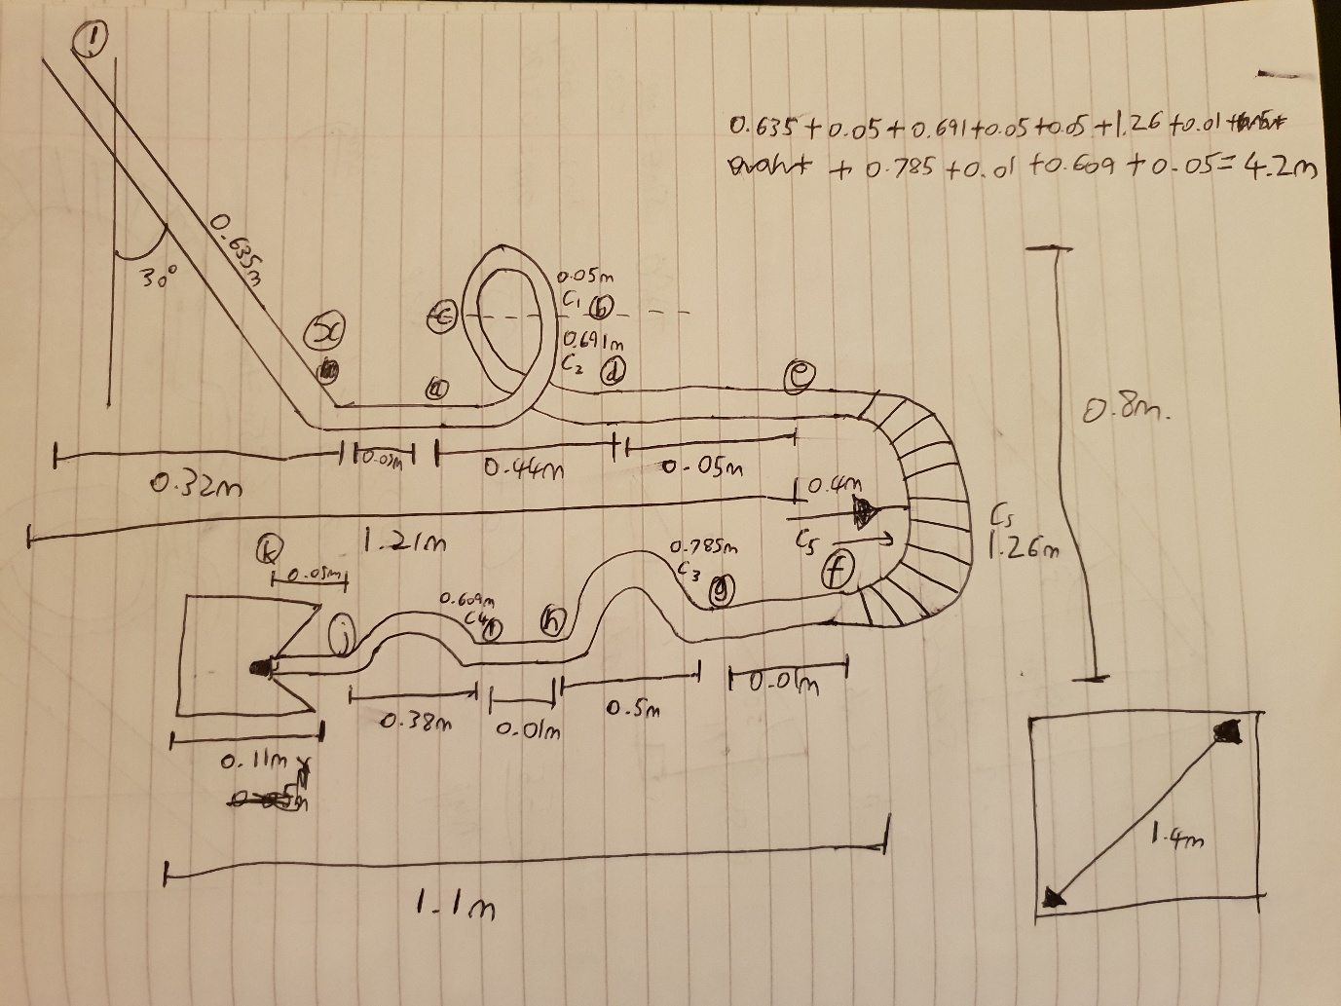Sketch 3 shows the assembled, dimensioned layout of the full roller coaster:
- Full track length and footprint dimensions are provided.
- Placement and integration of all components are clearly marked.
- The layout was used to verify that the model met space constraints and could be tested under controlled conditions.
The final model was constructed according to this plan and tested successfully. Data was logged via the light gate and stop contact system and reviewed on a computer for analysis.

Outcome
The marble roller coaster successfully demonstrated the intended dynamics and met all design requirements. It offered valuable hands-on experience in:
- Prototyping and structural design
- Application of physics principles (energy, forces, motion)
- Data collection and system integration
- Technical sketching and dimensioning
This project simulates the fundamental design and performance considerations involved in real-world roller coaster engineering and was a practical, educational success.

